Phillip Kimbrel

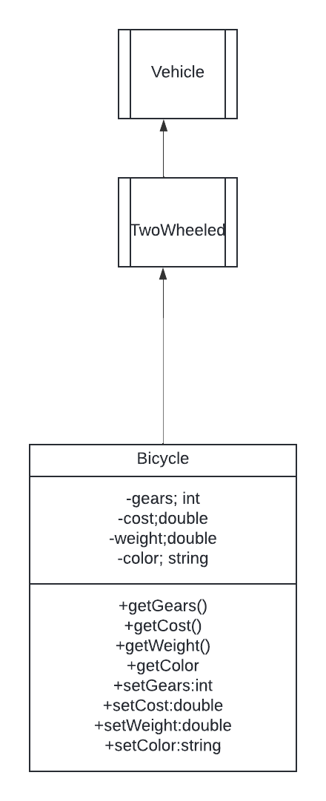

In this we are shown that Bicycle has Inheritance portability and polymorphism as the bike has inherited the vehicle and TwoWheeled classes. The Bicycle is also a self-contained object not requiring anything outside of its class. The Bicycle is also shows that is can also be considered TwoWheeled and a vehicle since it meets there requirements as well.